

Contents

Introduction On C++ Assignment 3

Task1-I/O File Manipulation(Coding Page) 3

Task1-I/O File Manipulation(Output Screen) 5

5

6

Task2-Inheritance 9

Task2-Inheritance(coding page) 10

Task2-Inheirtance (output screen) 12

Task3-Polymorphism 15

Task3- Polymorphism (Coding Page) 16

REFRENCES 21

References 21

# Introduction On C++ Assignment

In this Assignment, Task1-I/O Manipulation that contains file name i.e., product file that contain four kinds of output processing named (name of the product, Product ID, Product Category, Quantity on Hand). Furthermore, there are three categories of product: Electronics, Household and Furniture which will come under the processing output of Product Category. Another part of this Assignment is Task2-Inheritance that contain the explanation of Inheritance Concept, the aid diagram and explaining how Inheritance between classes can be applied in the “Product File” that has already created in Task1. The last part of Output Process is theTask3-Ploymorphism that contain explanation of Polymorphism Concept with the help of aid diagram and implementation of C++ classes in “Product File” that has already created in Task1.

# Task1-I/O File Manipulation(Coding Page)

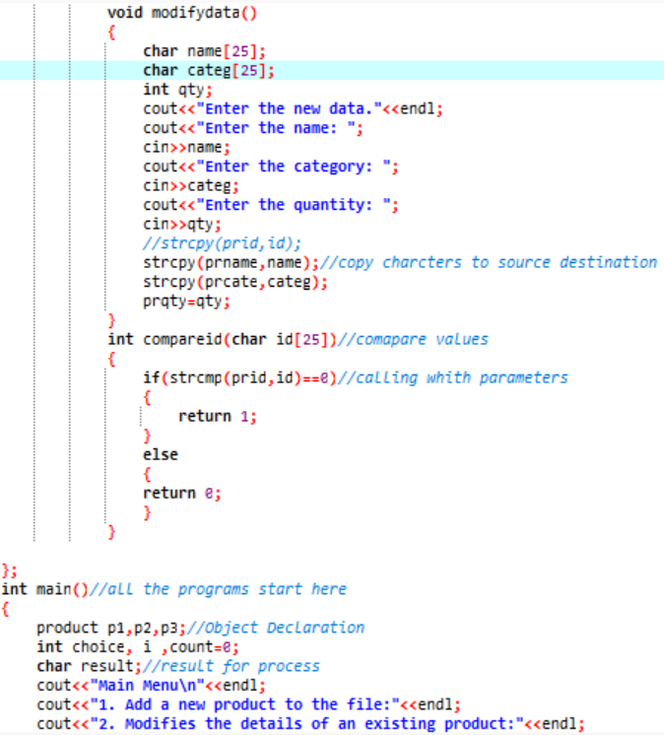

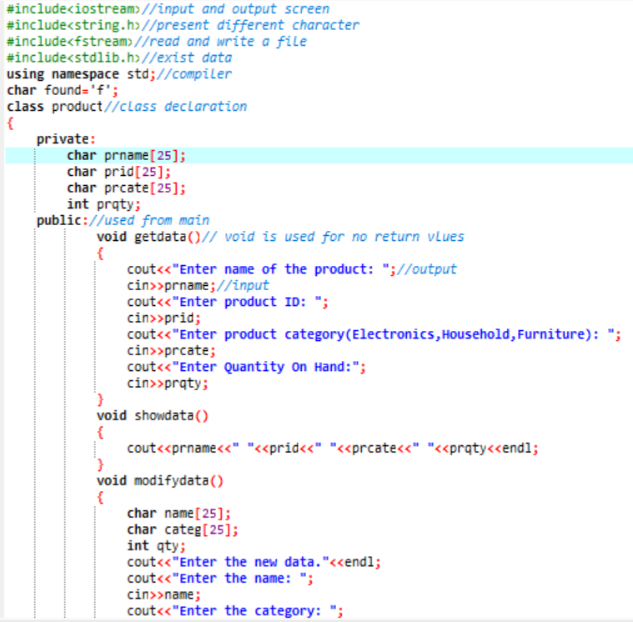

This first two page is Task1-I/O Manipulation coding in which the product of class was declared with Private specifier with the four-variable shown in the first snap. Public Class specifier is being used by void function (get data, show data, modify data) to insert output and input variable to be seen in the program. In the void (Modify data), uses string character and integer quantity that has already declared in private specifier class for its outcome. Besides that, it has declared string copy of characters within parameters to source its destination. For the integer we compare values.

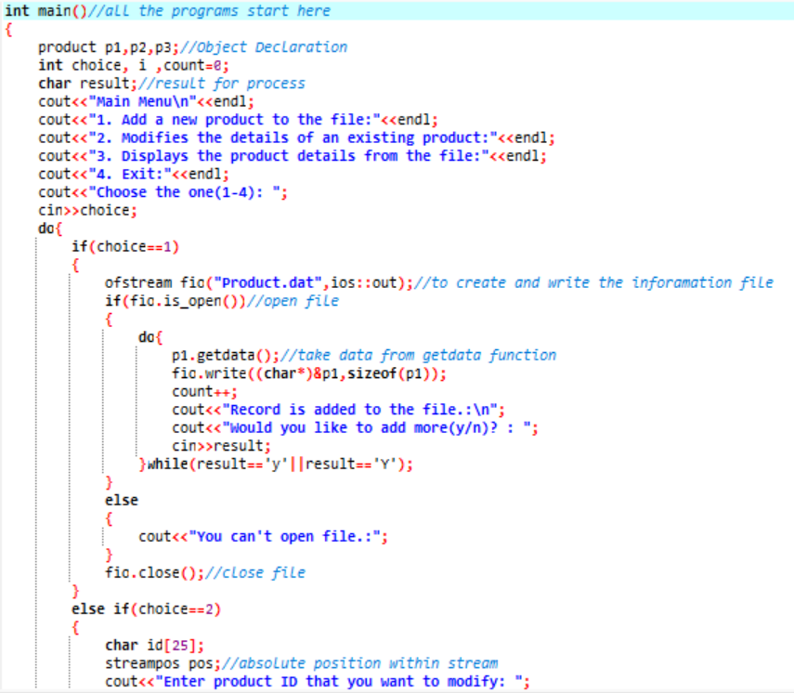

This is the third page in which integer main function is used to execute the program. In the main function, object was declared with the different variable not similar to class specifier variable to put a new data for the Add, Display and Modify Product.

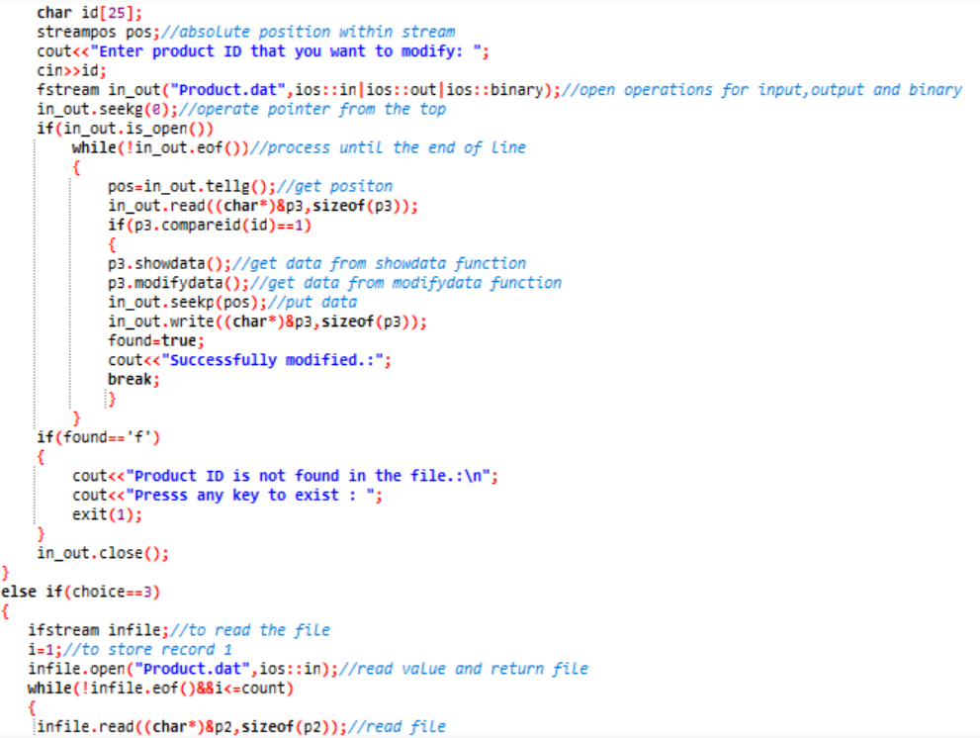

In Integer Main function, it is also used (do loop) mechanism for its looping until the user satisfy its implementing

the new data in the output. In the snap it also used to open file, take data from the previous get data and close file. The file name is “Procuct.dat”

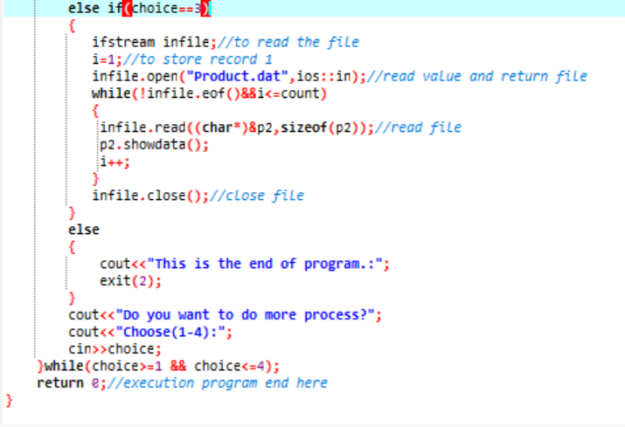In this snap consist of using do while loop and the return to Main menu and to execute the Program.

# Task1-I/O File Manipulation(Output Screen)

# 

This is the first output screen of program that will come after compile and run in Dev C++ after the debugging all the code. This code consists “Main Menu” as a title by following lists:

* Add new product to the file
* Modifies the details of an existing product
* Display the product details from the file
* Exit

Note: At the bottom there is an option from (1-4): in which the user can choose any number given in the output screen to Add, Modify, display a product and exit from the output screen.

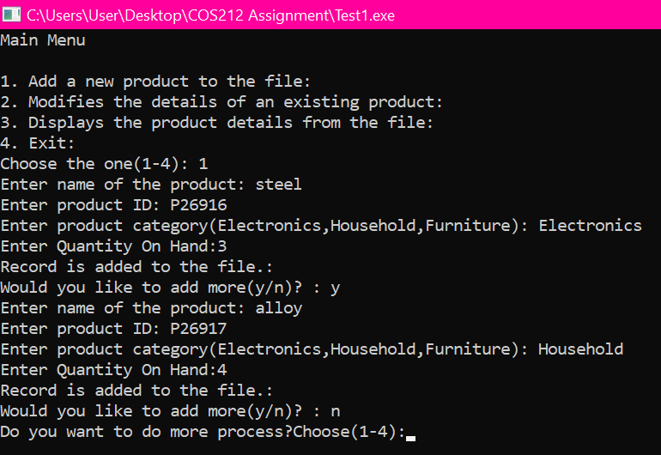In this output screen the user chooses the option 1 to add a new product to the file.

1.The user add the “steel” in the name of the product.

2.By following, the user adds the Product ID “P26916” in the second one.

3.The user add the Product Category named “Electronics” in the third one.

4.The user add “3” in the Quantity on Hand in the fourth one. Then the product is added to the file and so on.

Note: If the user writes yes “Would you like to add more(y/n)”in the output program screen the program will ask the user to add a new product. Whereas, if the user writes no then the program will directly move to Main Menu.

# 

In this output the user has already added the new product record to the file. After the user choose the option 3 which is basically the displaying the product details that user has added in the Product File. The records are steel, P269816, Electronics and 3 etc.

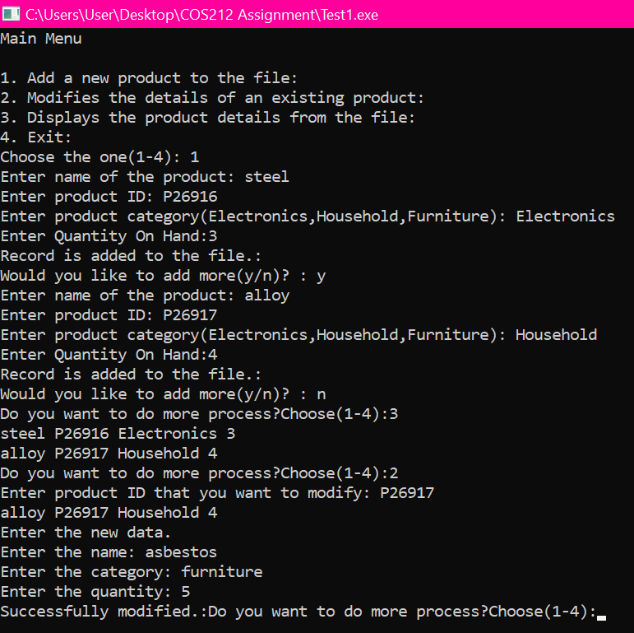

In this output program screen the user chooses the option 2 to modify the data that has recorded and display in the file .The user Modify the Product ID by entering the new name of the product, quantity and the category of the existing file. The user enter asbestos in the new product, furniture in the new category and 5 in the new amount of quantity.

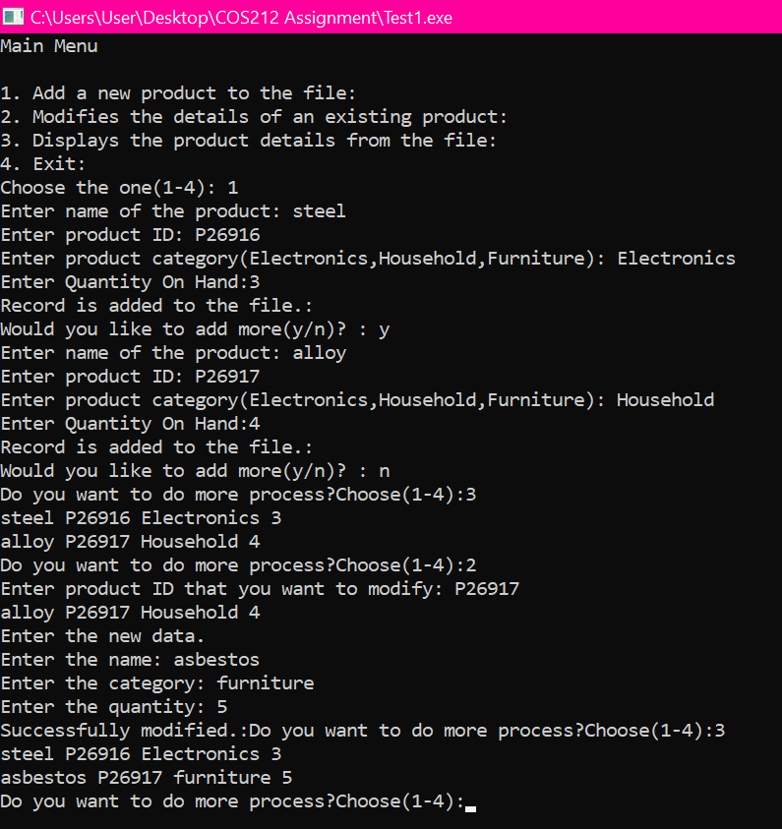

In this output screen the program displaying a modified product by choosing the option 3 from Main Menu. It display steel P26916 Electronics 3 in the first line. Another display is asbestos P26917 furniture 5 in the second line.

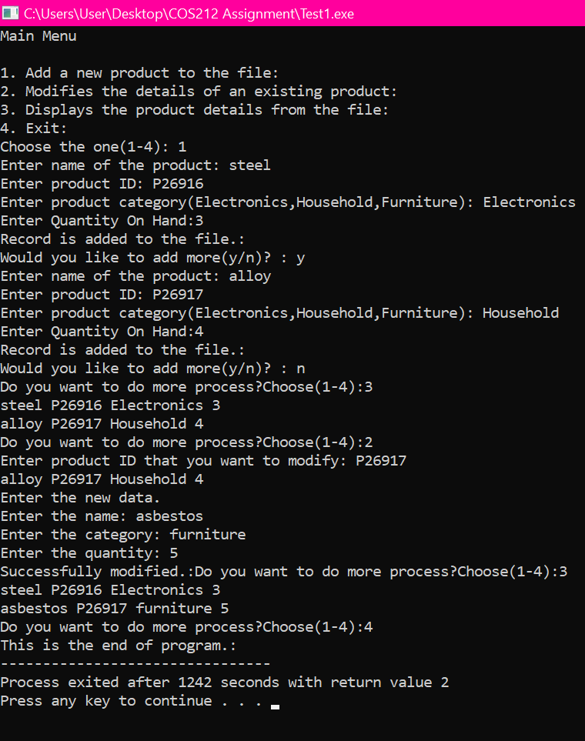

This is full programming page in which it shows all the operations starting from “Add a new product from the file to the exit file”. In this output screen the user chooses the option 4 to end the execute program to close the all the file.

# Task2-Inheritance

In object-oriented programming, inheritance is among the most crucial ideas. It is simpler to design and manage applications when we can declare a class in terms of another class, thanks to inheritance. Additionally, it allows for quick implementation times and code functionality to reuse. Programmers have the option to specify that a new class should inherit the members of an existing class rather than writing entirely new data members and member functions. The new class is referred to as the derived class, and the current class is known as the base class. In other words, Inheritance is the process by which new classes called derived classes are created from existing classes called base classes. The derived classes have all the features of the base class and the programmer can choose to add new features specific to the newly created derived class. (Anon., 2016).

In a C++ class, the access specifier defines the access control rules. These are:

* Public Specifier
* Private Specifier
* Protected Specifier

There are some points that need to be remember while Using Public, Private and Protected specifier:

* A derived class can access the protected and public members (data and functions) of a base class (for all three types of inheritance: public, protected, and private).
* Objects of derived classes with private and protected inheritance are not permitted to any data member of a base class that can be accessed.
* Only the base class's public members are accessible to objects of derived classes with public inheritance.

**Parent Class**

**Child Class**

Operation

char prid[25]

char prname[25]

char prcate[25]

int prqty

Function

voidModifydata()

Int strcmp()

Function

voidgetdata()

voidputdata()

# Task2-Inheritance(coding page)

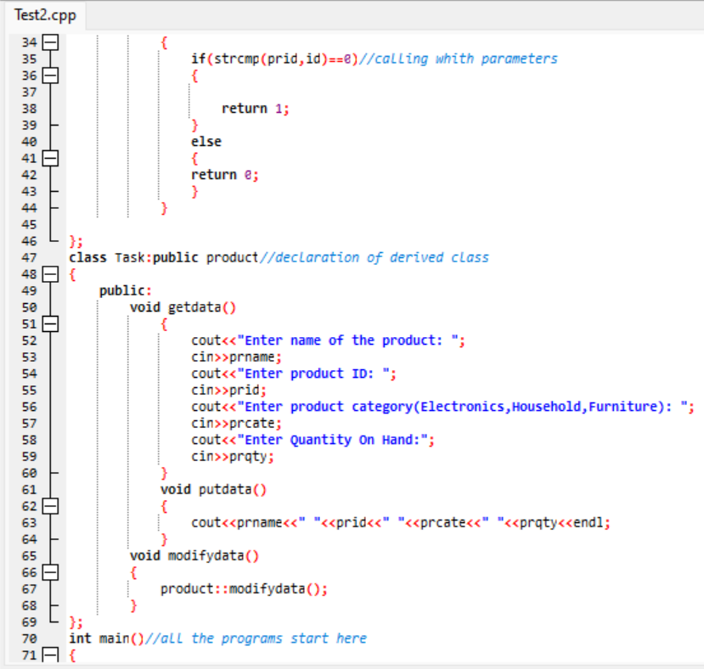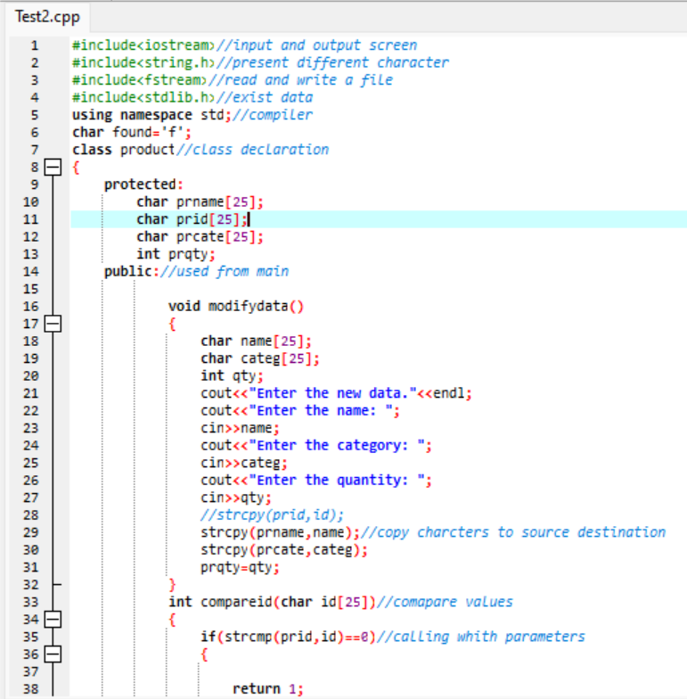

This is the first two page of inheritance coding in which the class has declared name product with the protected and public specifier. Void modify data is used for product name [25], category [25] and the quantity. String copy is used to copy the characters and to it source destination. After if function is used there was a declaration of different derived class of variable name “Task” with the public specifier. Void get data, put data and modify data is used to outcome the output result.

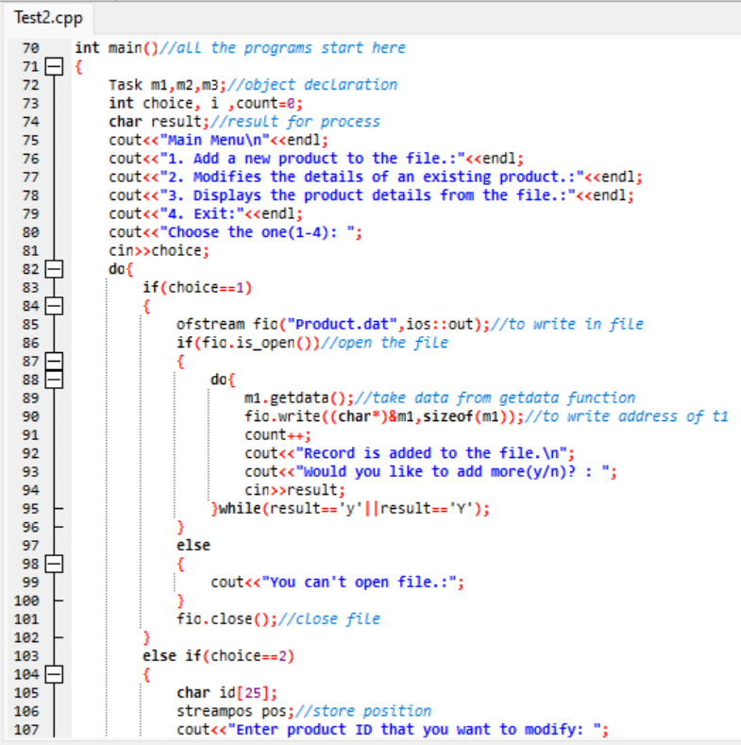The integer main function is used in this snap. Integer main function is the place where all the programs execute. The object was declared in the main function named Task m1, m2, m3. The character result used for the processing result. Do while loop is used in this snap create the file to write and read the input and output. The variable name m1, m2 and m3 is used with the void function to recall the data function. The name of the file is “Product.dat”

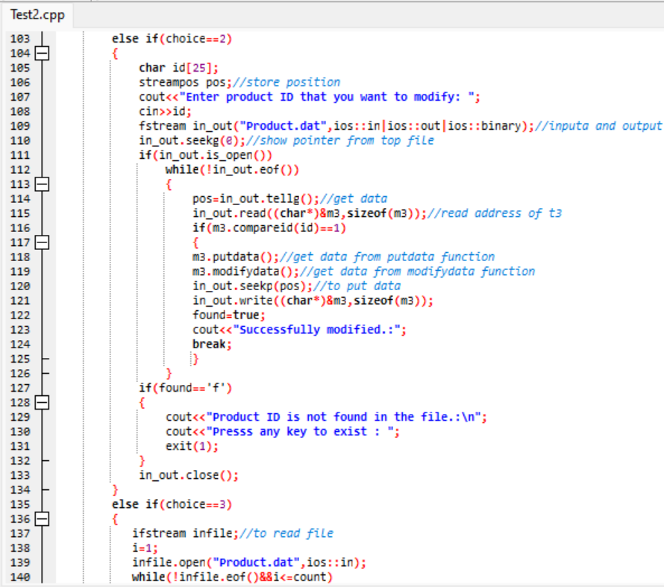

In this snap store function is also used to store the input new data. Addition on it, tell g function is also used to get data and the rest of the explanation is similar on the above page.

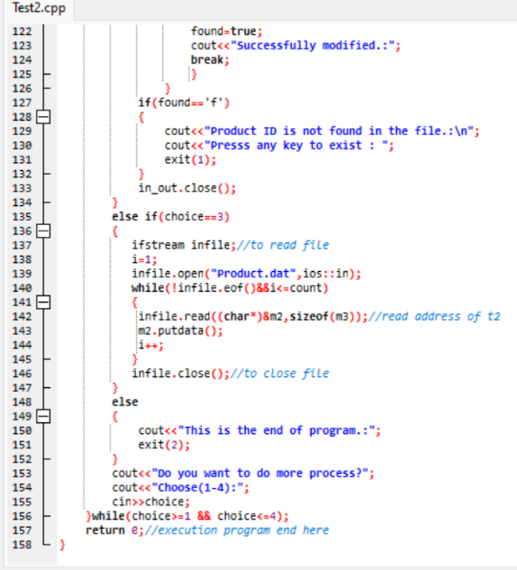

In this snap recalling that addresses to read the address. The rest is similar to above page. While loop is recalled the return 0 is to end the program.

# Task2-Inheirtance (output screen)

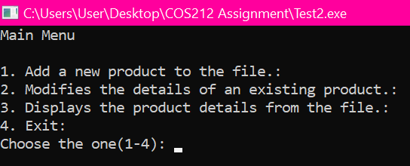

This is the first output screen of program that will come after compile and run in Dev C++ after the debugging all the code. This code consists “Main Menu” as a title by following lists:

* Add new product to the file
* Modifies the details of an existing product
* Display the product details from the file
* Exit

Note: At the bottom there is an option from (1-4): in which the user can choose any number given in the output screen to Add, Modify, display a product and exit from the output screen.

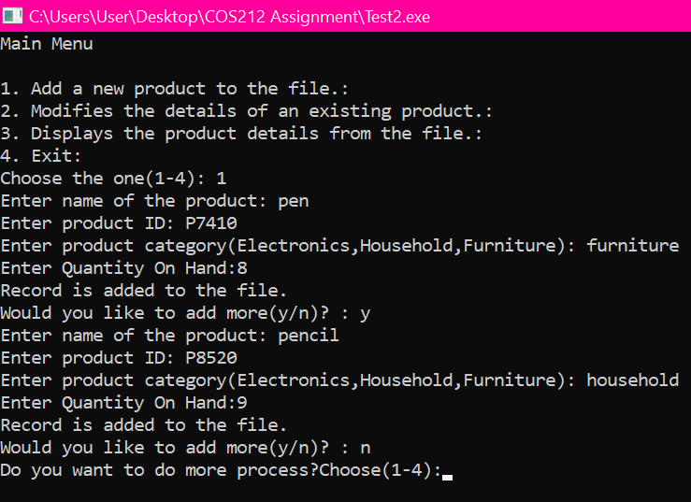

In this output screen the user chooses the option 1 to add a new product to the file.

1.The user add the “pen” in the name of the product.

2.By following, the user adds the Product ID “P7410” in the second one.

3.The user add the Product Category named “Furniture” in the third one.

4.The user add “8” in the Quantity on Hand in the fourth one. Then the product is added to the file and so on.

Note: If the user writes yes “Would you like to add more(y/n)”in the output program screen the program will ask the user to add a new product. Whereas, if the user writes no then the program will directly move to Main Menu.

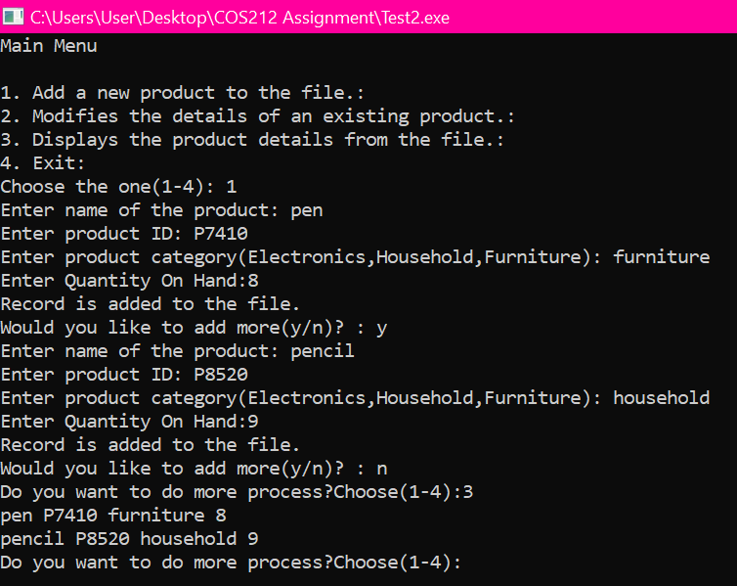

In this output the user has already added the new product record to the file. After the user choose the option 3 which is basically the displaying the product details that user has added in the Product File. The records are pen, P7410, Furniture and 8 etc.

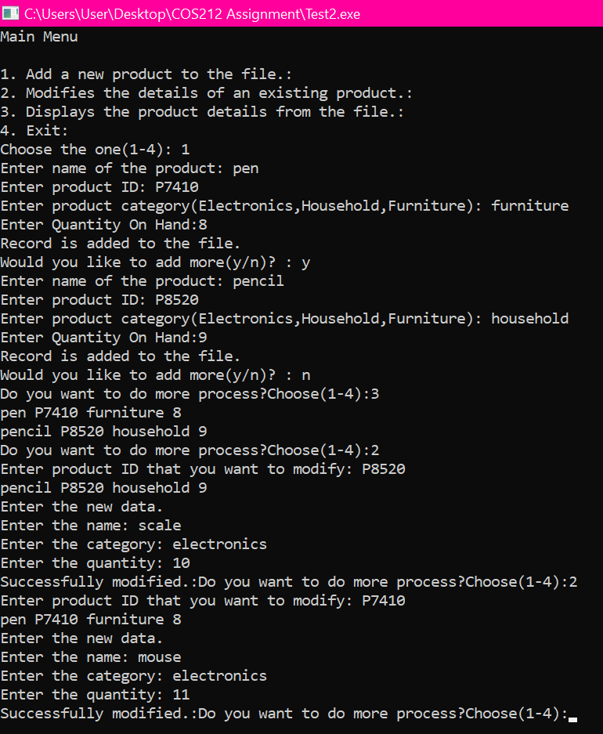

In this output program screen the user chooses the option 2 to modify the data that has recorded and display in the file .The user Modify the Product ID by entering the new name of the product, quantity and the category of the existing file. The user enter scale in the new product, electronics in the new category and 10 in the new amount of quantity. Again, the user enter mouse in the new product, electronics in the new category and 11 in the new amount of quantity.

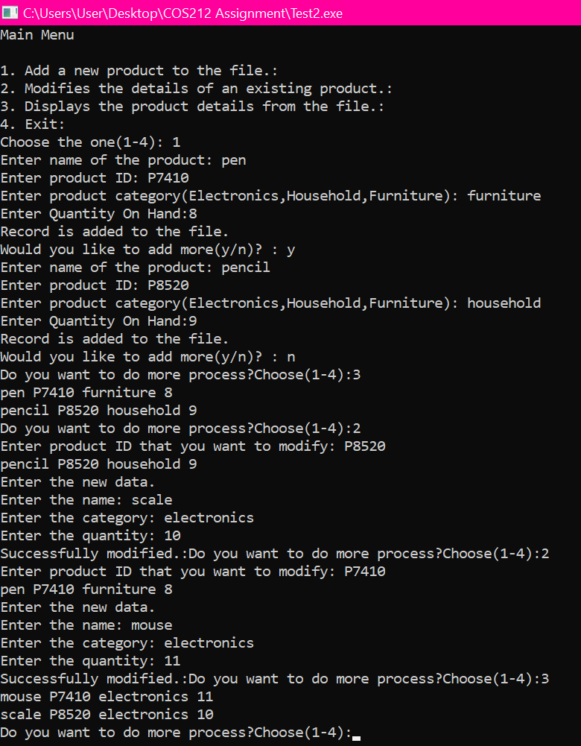In this output screen the program displaying a modified product by choosing the option 3 from Main Menu. It displays mouse P7410 electronics 11 in the first line. Another display is scale P8520 electronics 10 in the second line.

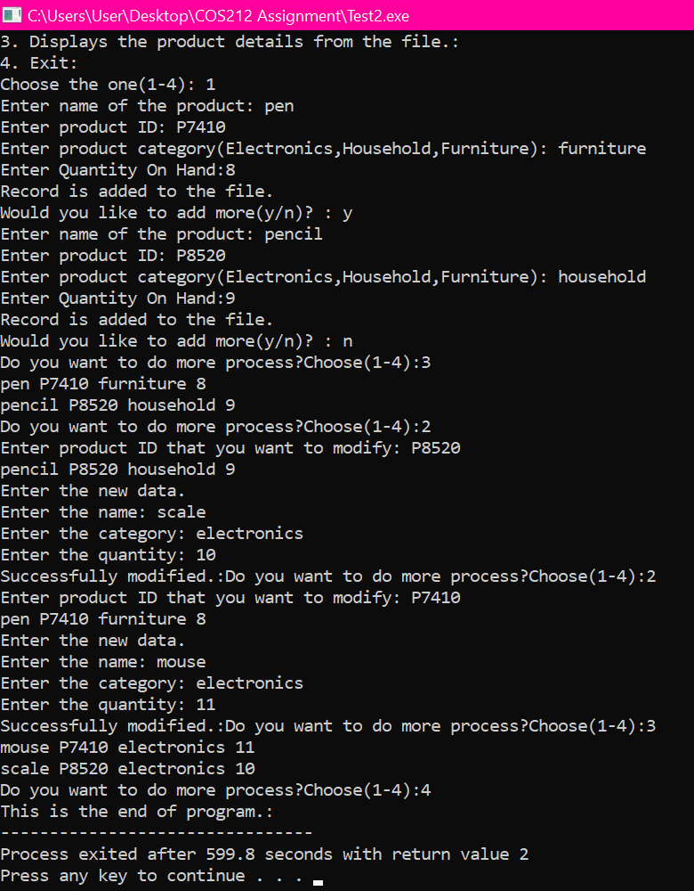

This is full programming page in which it shows all the operations starting from “Add a new product from the file to the exit file”. In this output screen the user chooses the option 4 to end the execute program to close the all the file.

# Task3-Polymorphism

Polymorphism is defined as "taking several forms." Whereas inheritance allows subclasses to share, polymorphism allows subclasses to distinguish themselves from one another. The term polymorphism refers to having several forms. Polymorphism is the ability of a message to be presented in more than one form. In real life, a person might have many characteristics at the same time. Like a man, he is a father, a spouse, and an employee all at the same time. As a result, the same person exhibits diverse behavior in different settings. This is referred to as polymorphism. Polymorphism is regarded as an important element of Object-Oriented Programming.

**Parent Class**

**Child Class**

Operation

char prid[25]

char prname[25]

char prcate[25]

int prqty

Function

Virtual void getdata()

Virtual void putdata()

Virtual void modifydata()

Virtual int strcmp()

Function

voidgetdata()

voidputdata()

voidmodifydata()

int strcmp()

# Task3- Polymorphism (Coding Page)

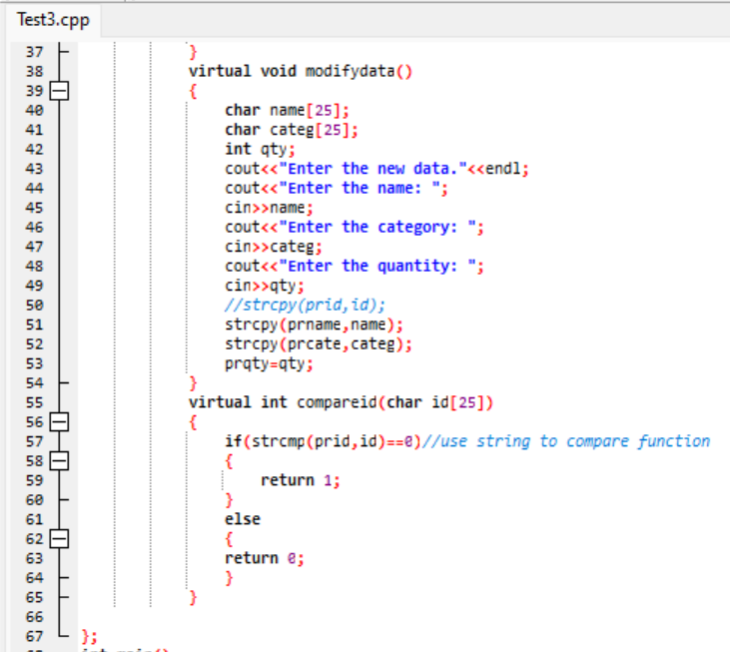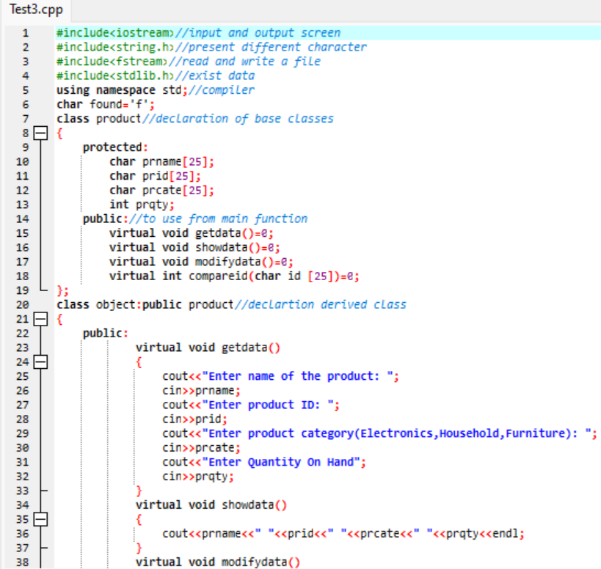

In these two snaps there is a declaration of base class named “Product” related to the Protected and public specifier with variable name and virtual void function such as get data, put data, show data and modify with the parameters open which is equal to zero. The object class is created with the public specifier product which is basically derived class. Applying the virtual void get data, show data and modify data integer compare Id. Alongside, string copy is also used compare function.

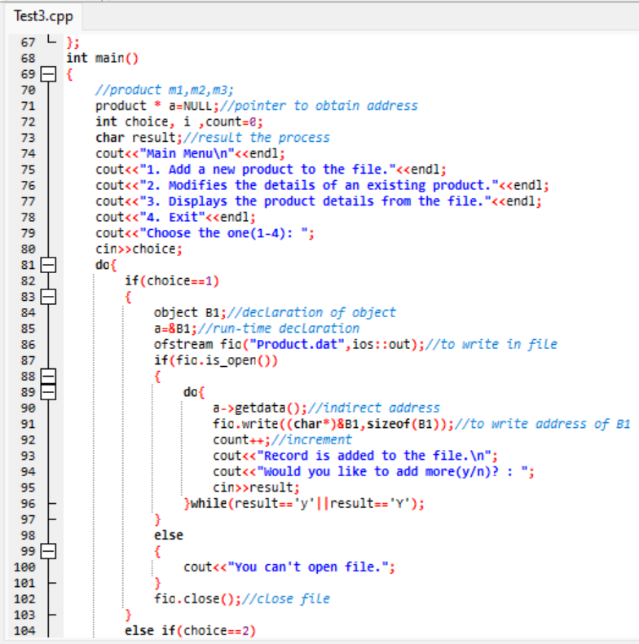This snap consists of main function in which all the program start. A Null is also used to obtain the pointer address. Do while loop is also used for looping for object B1, B2, and B3. Get data function is also used for indirect address.

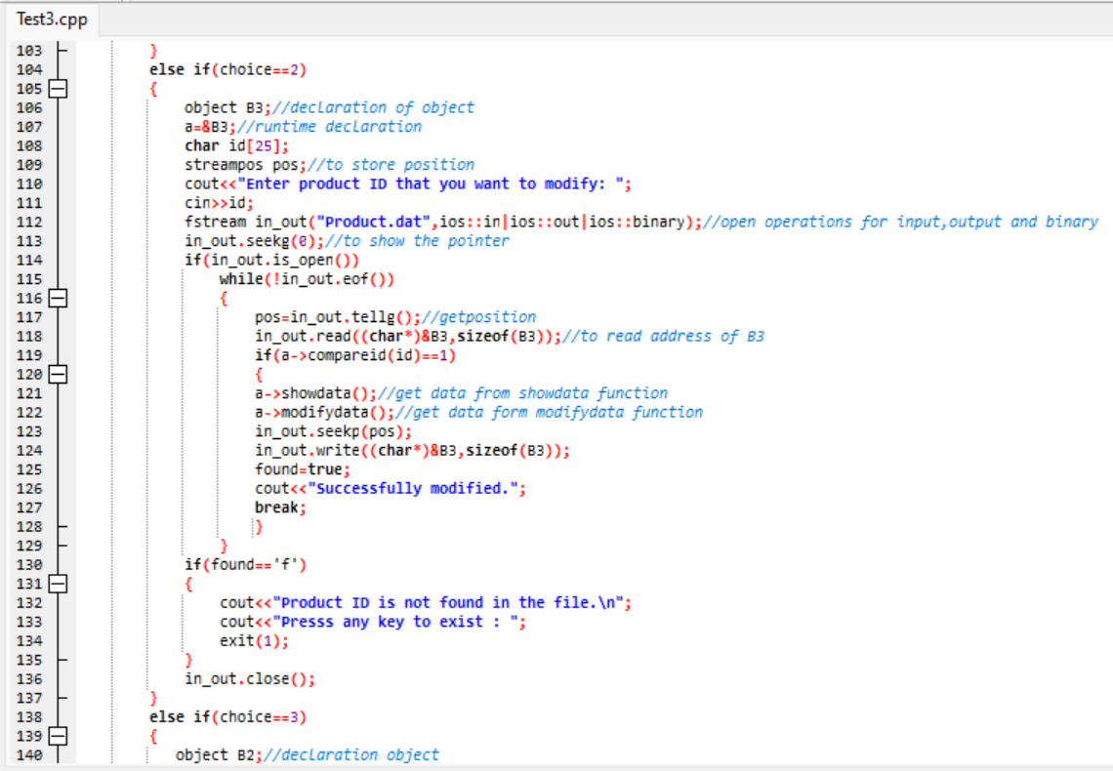

In this snap object the declaration is B3 and it has also use stream function to store position. “If” function is also used to open and get the position in file.

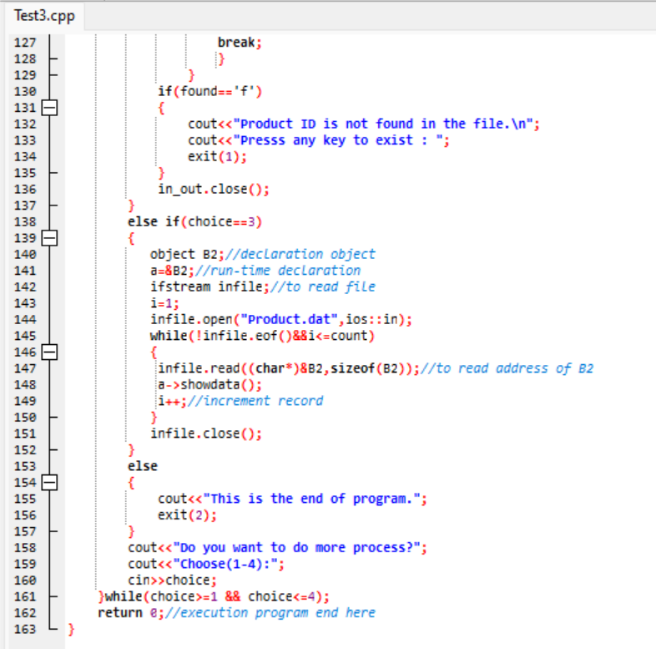

In this snap object the declaration is B2 and it has also use stream function to store position. “If” function is also used to open and get the position in file. This is the end page of the code.

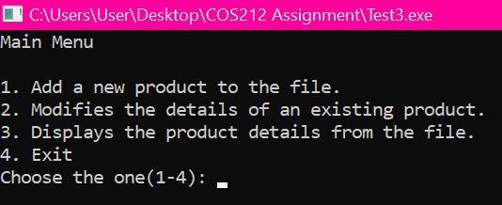This is the first output screen of program that will come after compile and run in Dev C++ after the debugging all the code. This code consists “Main Menu” as a title by following lists:

* Add new product to the file
* Modifies the details of an existing product
* Display the product details from the file
* Exit

Note: At the bottom there is an option from (1-4): in which the user can choose any number given in the output screen to Add, Modify, display a product and exit from the output screen.

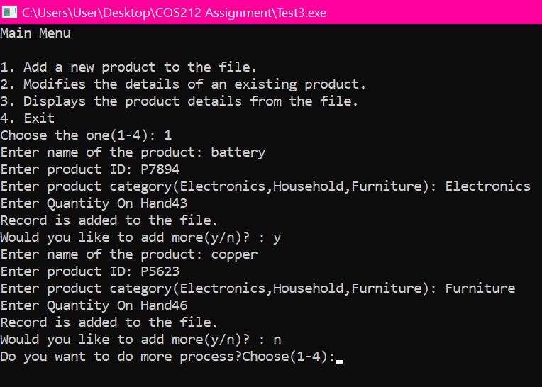In this output screen the user chooses the option 1 to add a new product to the file.

1.The user add the “battery” in the name of the product.

2.By following, the user adds the Product ID “P7894” in the second one.

3.The user add the Product Category named “Electronics” in the third one.

4.The user add “43” in the Quantity on Hand in the fourth one. Then the product is added to the file and so on.

Note: If the user writes yes “Would you like to add more(y/n)”in the output program screen the program will ask the user to add a new product. Whereas, if the user writes no then the program will directly move to Main Menu.

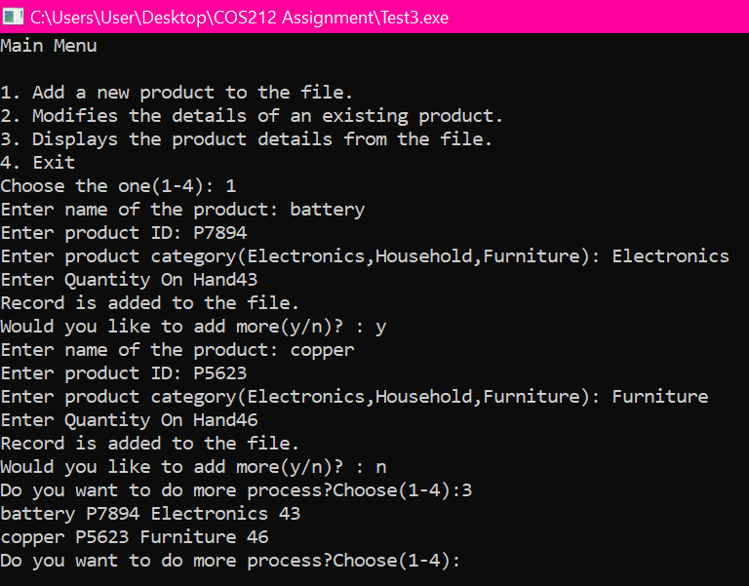

In this output the user has already added the new product record to the file. After the user choose the option 3 which is basically displaying the product details that user has added in the Product File. The records are battery, P7894, Electronics and 43 etc.

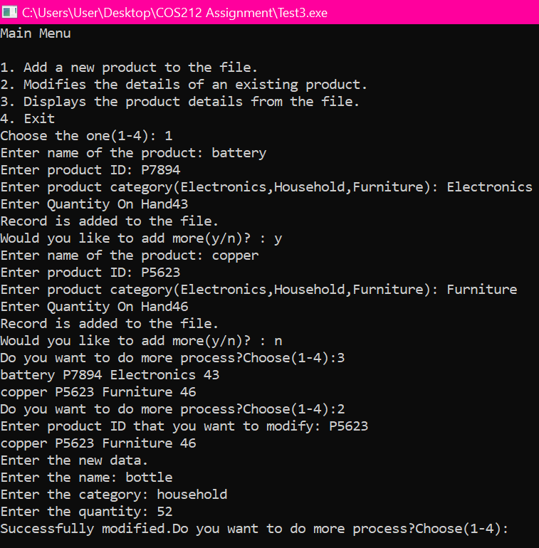

In this output program screen the user chooses the option 2 to modify the data that has recorded and display in the file .The user Modify the Product ID by entering the new name of the product, quantity and the category of the existing file. The user enter bottle in the new product, household in the new category and 52 in the new amount of quantity.

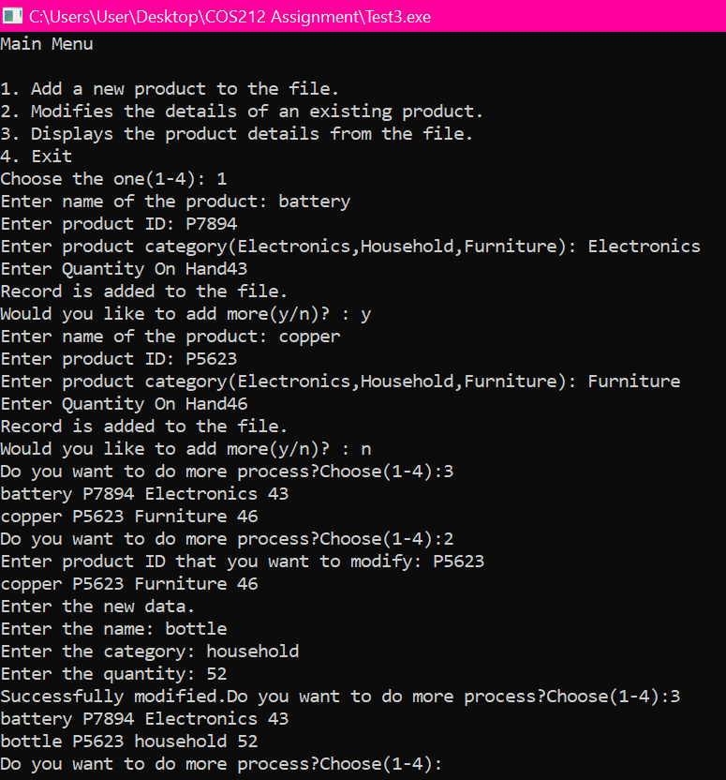

In this output screen the program displaying a modified product by choosing the option 3 from Main Menu. It displays bottle P5623 household 52 in the first line.

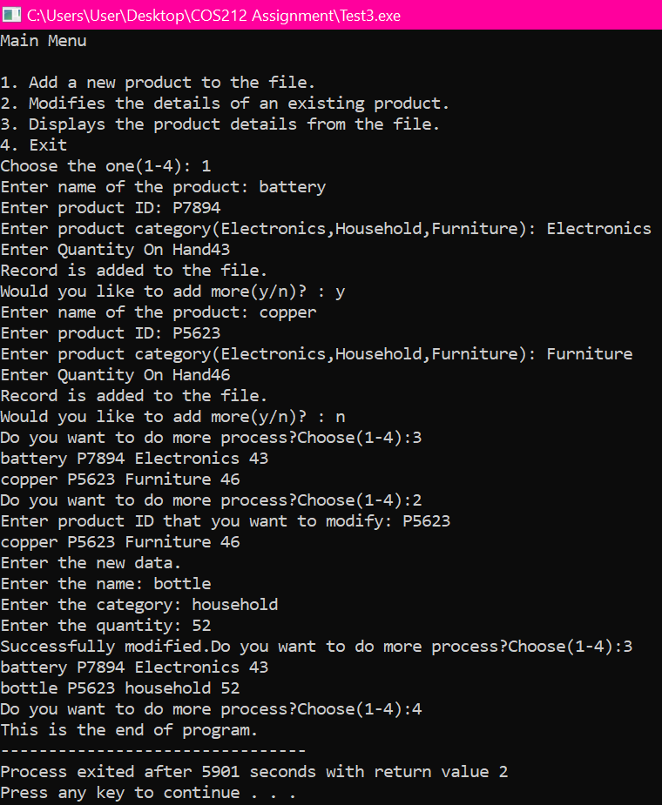

This is full programming page in which it shows all the operations starting from “Add a new product from the file to the exit file”. In this output screen the user chooses the option 4 to end the execute program to close the all the file.

# REFRENCES

# References

Anon., 2016. *Inheritance [Compatibility Mode].* [Online]   
Available at: https://www.sctce.ac.in/faculty/facultylogin/Admin/Attachments/Upload/1548822344_1548822344.pdf  
[Accessed 25 July 2022].